|  |  |  |
| --- | --- | --- |
| Gear Shift | | |
| Game Design Document | | |
|  | | |
| A One-Button Mechanical Adventure | | |
|  | | |
|  | | |
| Art by Sebastian Beltran Convers | | |
| **Capybara Studios** | | |
| Andre Borja Miranda  Eduardo Cavalcante Almeida  Naomi Freire Nagayama  Sebastian Beltran Convers | | |
|  | | |
|  | | |
|  | Table of Contents  Overview 2  Description 2  Goals 2  Pillars 2  Hook 2  3 Cs 2  Character 2  Camera 2  Controls 2  Features 3  Toothed Surfaces 3  Gravity Inverters 3  Keys 3  Tubes 4  Bubble Gum 4  Production 4  Kanban Board 4  Team Members and Responsibilities 4  Risks and Mitigation 4  Publishing 5  Art 5  Tech 5  Audio 5  UI 5  Post-mortem 5  What went right 5  What went wrong 6  What we learned 6 |  |

# Overview

## Description

A one-button 2D puzzle platformer with the core mechanic of gravity shifting.

## Goals

This game, a 2D platformer, has the main goals of implementing a single button input system and exploring the different sorts of maps that can be achieved when gravity shifting is a essential part of movement.

## Pillars

Three pillars that will help inform your design decisions.

1. One Button – the game is supposed to take input from a single button. In our case, that button is ‘Space’ and the action attached to it is jumping.
2. Movement – the character slides through the surfaces at all times and the only player verb is jumping. These are the essential means of completing the game.
3. Satisfying – movement alone is aimed at being satisfying. Jumping from platform to platform, changing directions and collecting keys are all parts of an experience that should be as smooth and endorphin-inducing as possible.

## Hook

A one-button 2D puzzle platformer with the core mechanic of gravity shifting.

# 3 Cs

## Character

A little cog named Coggi is an essential component of a Robot's heart. The Robot's condition has deteriorated over time due to the irregular amount of bubble gum spread across its surfaces.

The only way to clear out the bubble gum is by unlocking the tubes that connect the Robot’s organs and allowing to flow normally. Coggi is the only cog whose shape matches the keys needed to unlock these tubes.

Coggi's main mission is to find these keys by spinning through the surfaces, jumping between platforms and inverting the gravity to access different parts of each organ. This will all be done by automatic impulse and the press of a single button: 'Space' to jump.

## Camera

Side-view camera that follows Coggi across the levels.

## Controls

Spinning is the essence of Coggi’s movement. Coggi spins automatically and flips directions when colliding with walls. Tapping the SPACE button makes it jump.

# Features

## Toothed Surfaces

Metallic (brass), shiny, geometric. These are the surfaces which Coggi automatically spins through, as their shape match his. He travels in the same direction unless he collides with a different object or surface.

## Gravity Shifters

Gravity shifting is enabled by colliding with cogs that are displayed across the levels. The Gravity Shifters establish the gravity in four dimensions: Down, Up, Left and Right.

## Keys

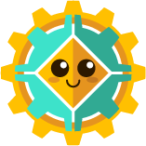The Keys are the collectibles needed to unlock the tubes and get through each level. Once picked up, they become a part of Coggi’s shape.

## Tubes

The tubes are located at the beginning and end of every level. The first one sets the starting position for Coggi and the second is blocked off until Coggi has acquired all the keys. Once he has all of them, he can go through, advancing to the next level, and leaving behind the keys that he found in the previous one.

## Bubble Gum

Pieces of pink gunk that are stuck on surfaces and once collided with, stop Cog’s movement entirely, essentially killing him. They are stationary.

# Production

## Kanban Board

https://trello.com/b/s54CryK1/gears-of-more

## Team Members and Responsibilities

|  |  |
| --- | --- |
| Team Member | Main Responsibilities |
| Andre Borja Miranda | Programming |
| Eduardo Cavalcante Almeida | Level Design |
| Naomi Freire Nagayama | Project Management, Art |
| Sebastian Beltran | Game Design, Art |

## Risks and Mitigation

Identify any risks and their possible mitigations. Add more rows as needed. Check example below.

|  |  |
| --- | --- |
| Risk | Mitigation(s) |
| Team has never made a game in two weeks | Establish priorities and work with them in mind from the start. Adding details only when prioritized tasks are completed. |
| Team has never made a one-button game | Work to tie all maps together by the use of the one button. |

## Publishing

https://naomifreire.itch.io/gear-shift

# Art

Inspired mainly by moving pieces like those seen in watches, clocks and other machinery. Steampunk elements converted to flat design aesthetic.

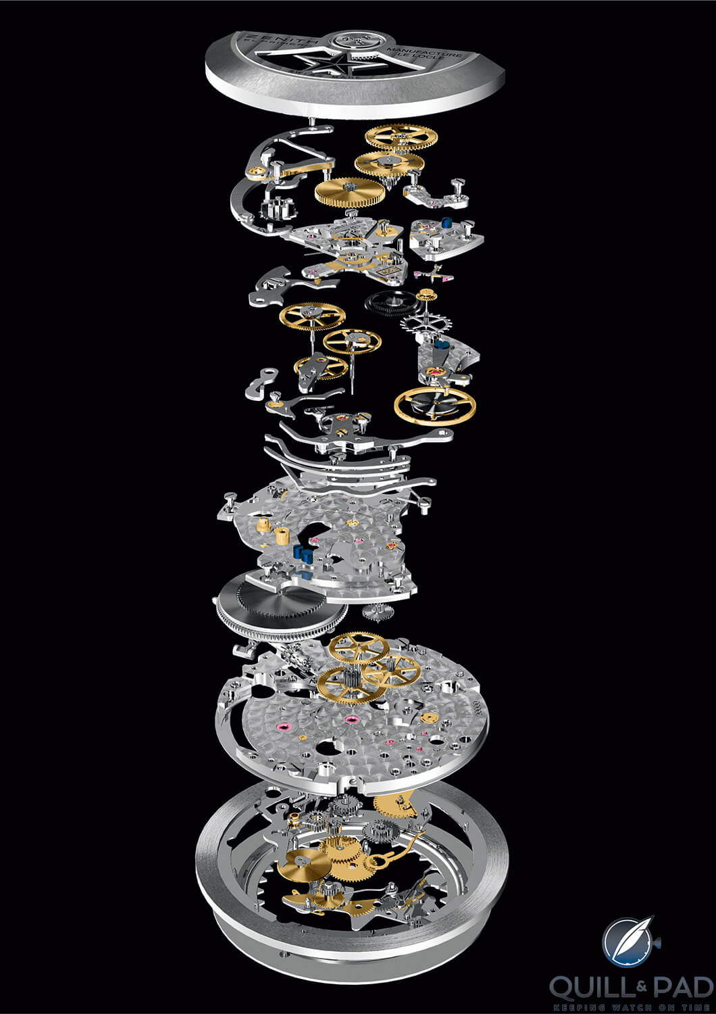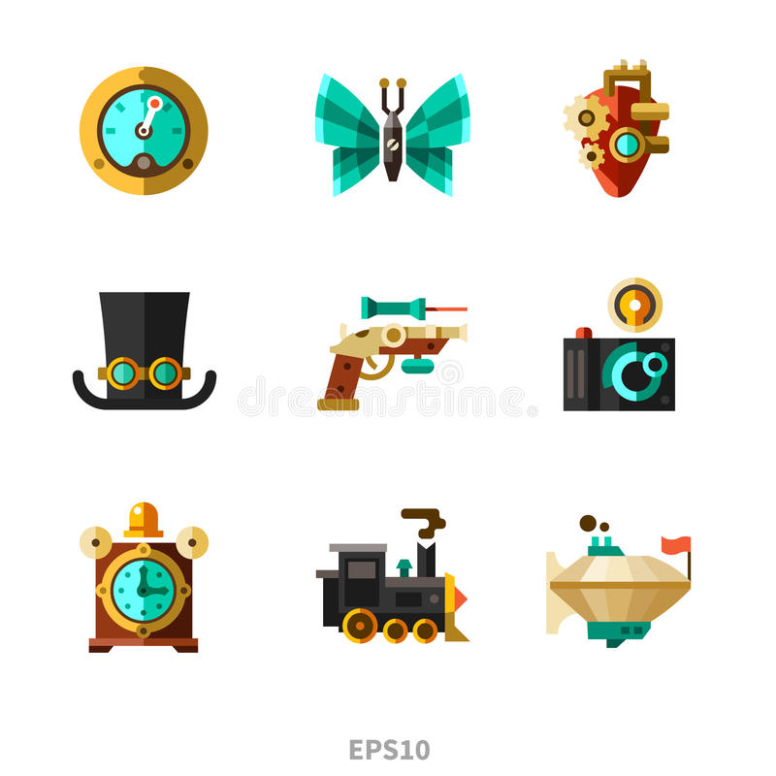

# Tech

We are using the Unity game engine with the Text Mesh Pro plug-in.

# Audio

Since one of the games pillars is satisfaction, the audio direction has always aimed at gathering sounds that fit the theme and the actions attached to them as well as providing the player with feedback that rewards and satisfies.

# UI

The UI in this game is minimal. The main menu displays the cover art and the prompt for starting the game. The HUD consists only of the key count per level, which is the only collectible to keep track of. The end menu displays the logo and a congratulations for finishing the game.

# Post-mortem

## What went right

* Character creation - character that is iconic, minimalistic yet appears clearly onscreen, with attachable pieces and a nice base design that stands on its own.
* Movement is stable with gravity shifting.
* We kept the project within scope and knew how to prioritize according to the essence of the game concept.

## What went wrong

* We initially wanted to create sinuous levels where the cog could spin through any surfaces that whose teeth matched his. The one button input would be tied to jumping as well and changing surfaces would happen automatically on collision. All these elements together proved to be a much bigger programming challenge than we were expecting (the challenge would blow the game out of scope for its production time of two weeks), so we decided to stick to the core feature of alternating surfaces which the player can spin through.
* The initial concept was a 2D platformer where the level works as a puzzle that fits entirely on screen and rotates around the character.

## What we learned

* Using tile palettes for level design saves time.
* Creating trim sheets to memory space.